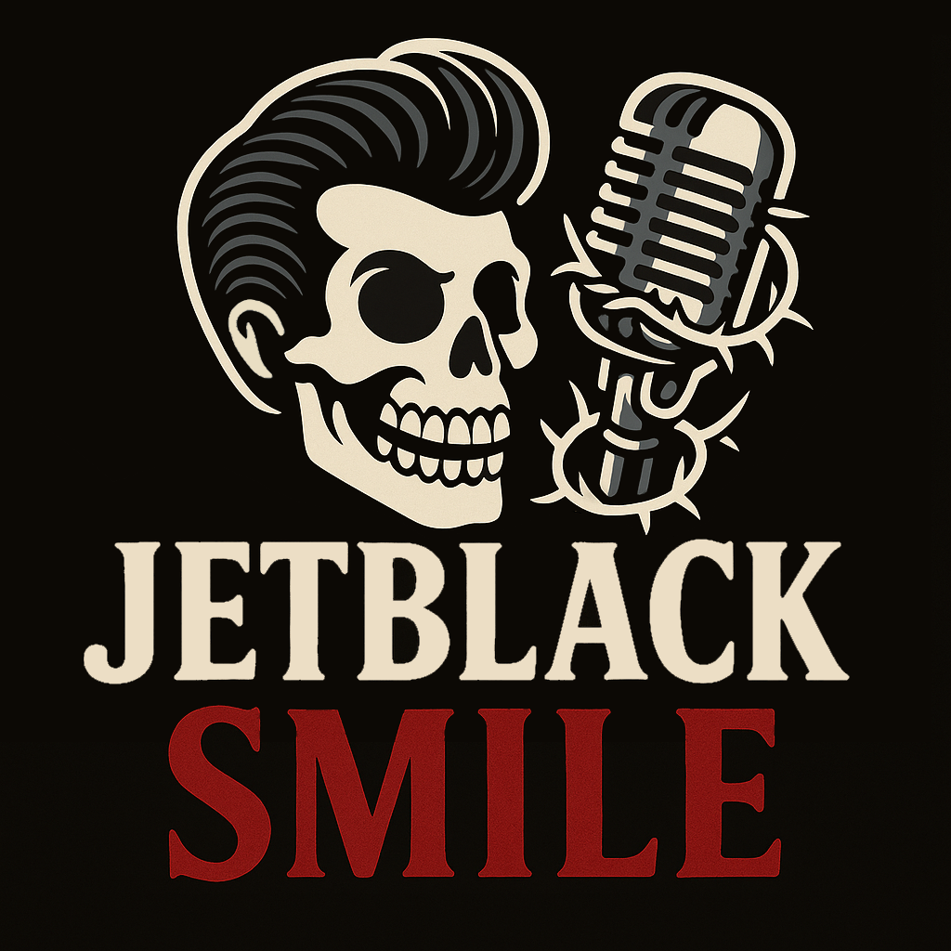
JetBlack Smile
Setlist Boelare Rock 16/8/2025

- Money - train beat
- Swipe Right - meteen drum starten
- Fakin’ it fine - gitaar intro
- Unspoken - aftikken
- Gone with my cash - brushes
- Left on Read - Elvis - aftikken
- Nothing to lose - gitaar intro
- It ain't half bad - waterpijp intro
- Domestic Cage - meteen aftikken hihat

